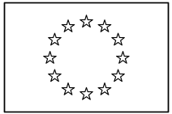 | EUROPEAN COMMISSION  DIRECTORATE-GENERAL  INFORMATICS  Information Systems Directorate

European Commission
UC0190 - e-TrustEx Admin Console - Manage SLA Policies
UC0190 - e-TrustEx Admin Console - Manage SLA Policies

Date: | 23/01/201726/10/2016
Version: | 21.000001
Authors: | Anamaria BATRINU
Revised by: | Cristian CHIRIAC
Approved by:
Public:
Reference Number:
TABLE OF CONTENTS
1. Use-Case Description 5
1.1. Primary Actor 5
1.2. Definitions, Acronyms and Abbreviations 6
1.3. References 6
1.4. Context Diagram 6
2. Flow of events 6
2.1. Basic Creation Flow 7
2.1.1. User chooses the Create SLA menu action 7
2.1.2. System displays the "Create SLA Policy" page 7
2.1.3. User enters information 7
2.1.4. System creates the SLA Policy 7
2.1.5. User acknowledges and closes the confirmation Popup 8
2.1.6. System redisplays the saved SLA Policy in view mode 8
2.1.7. The basic creation flow ends. 8
2.2. Basic search flow 8
2.2.1. User selects the Search SLA Policy menu action 8
2.2.2. System displays the "Search SLA Policy" page 8
2.2.3. User enters the search criteria 8
2.2.4. The System searches the SLA policies 8
2.2.5. System displays the SLA policies found 8
2.2.6. User views the result list 9
2.2.7. The basic search flow ends. 9
2.3. Basic Visualization Flow 9
2.3.1. At 2.2.6, User clicks an SLA policy in the list 9
2.3.2. System opens the SLA policy visualization page (see 7.3 View SLA Policy page) 9
2.3.3. User visualises the details of the SLA policy: 9
2.3.4. Visualization flow ends. 9
2.4. Basic Modification Flow 9
2.4.1. At 2.3.3, User chooses to edit an SLA policy 9
2.4.2. System opens the SLA policy page in edit mode (see 7.4 Modify SLA Policy page) 9
2.4.3. User makes the changes 10
2.4.4. The system saves the modified SLA policy 10
2.4.5. User acknowledges and closes the confirmation Popup 10
2.4.6. System redisplays the SLA policy in view mode (see 7.3 View SLA Policy page) 10
2.4.7. The Modification flow ends. 10
2.5. Basic Deletion Flow 10
2.5.1. At 2.3.3, User chooses to delete an SLA policy 10
2.5.2. System displays a dialog window asking for deletion confirmation 10
2.5.3. User confirms the deletion 10
2.5.4. System deletes the SLA policy 11
2.5.5. System notifies user of the success of the operation 11
2.5.6. User acknowledges the message 11
2.5.7. The Deletion Flow ends. 11
2.6. Subflows 11
2.6.1. S1: at step 2.1.3 User chooses to search for a Transaction 11
2.7. Alternative Flows 11
2.7.1. AC1: at step 2.1.3, User chooses Cancel option 11
2.7.2. AC2: at step 2.1.3, User chooses Clear option 11
2.7.3. AC3: at step 2.1.4, Business Rules are not verified 11
2.7.4. AS1: at step 2.2.4, no SLA policy found for the specified criteria 11
2.7.5. AM1: at step 2.4.3, User chooses Cancel option 11
2.7.6. AM2: at step 2.4.3, User chooses Reset option 12
2.8. Exceptional Flows 12
2.8.1. E1: User is not authorized for the operations described in any of the basic flows. 12
3. Special Requirements 12
3.1. Interface(s) with other Systems 12
3.2. Security Requirements 12
3.3. Other Special Requirement 12
4. Preconditions 12
5. Post conditions 12
6. Additional Information 12
6.1. Includes 12
6.2. Extends 13
6.3. Database details 13
6.3.1. Database mapping 13
6.3.2. Table unicity constraint 13
6.4. Code lists 13
7. Mock-up screens 14
7.1. Create SLA Policy page 14
7.2. Search SLA Policy page 15
7.3. View SLA Policy page 16
7.4. Modify SLA Policy page 16
7.5. Delete SLA Policy page 17

Document History

Version | Date | Comment | Modified Pages
1.000 | 30/05/2016 | Creation. JIRA ETRUSTEX-1372 | All
1.001 | 26/10/2016 | ETRUSTEX-1392
2.000 | 23/01/2017 | ETRUSTEX-1937: Reorganizing CIPAdmin user roles

Use-Case Description
This use case depicts the sequence of actions that a user needs to take in order to configure a Service Level Agreement (SLA) Policy. A service level agreement policy applies to a transaction in a given business context. It also describes the management actions that correspond to an existing SLA Policy, such as Update, Delete, View and Search.
The "Service Level Agreement Management" feature is exposed on the CIPAdmin module of e-Trustex platform.
In the remainder of the document the CIPADMIN application will be referred to as the System.

Primary Actor
A humain user can access the Manage Service Level Agreement Policies feature via CIPAdmin interface.
For detailed user access rights on each feature option, please see UC 0100 - eTrustEx Admin Console - Authenticate and Authorise User, section 6.3 User Access Rights.
In the remainder of the document, the user will be reffered to as User.

Definitions, Acronyms and Abbreviations
Acronym, Abbreviation or Definition | Explanation
CIPA | Common Infrastructure for Public Administrations
CIPADMIN | CIPA AdminConsole
ADM | A user having General Administrator role. The General Administrator is the Administrator of the CIPAdmin application.
UC(s) | Use Case(s)

References
Ref. | Reference | Title / description | Version | Date
[R1]

Context Diagram
The diagram below depicts how this use case interacts with other use cases implemented in the Administration Console.
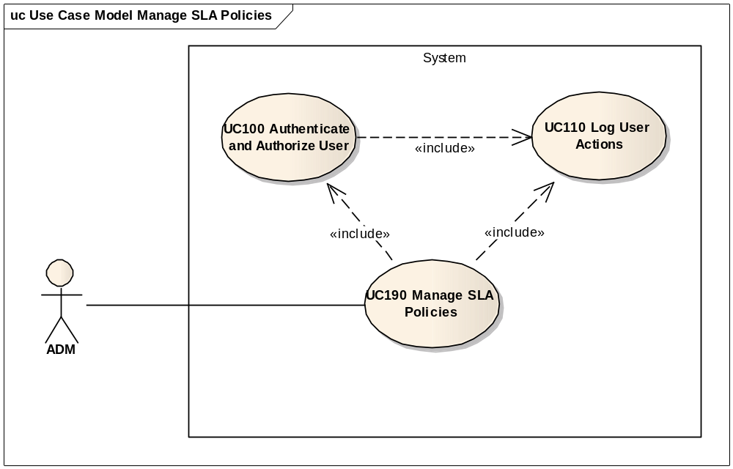

Flow of events
The conventions described in User Interface Generic Conventions document must be applied.

Basic Creation Flow
ID | Description
UC0190_BR01 | User needs to have the correct access rights in order to access this feature. Please see UC 0100 - eTrustEx Admin Console - Authenticate and Authorise User, section 6.3 User Access Rights for more information.

User chooses the Create SLA menu action
User selects the Create SLA menu option from the e-TrustEx Administration Console: Technical Configuration > SLA Policy > Create.

System displays the "Create SLA Policy" page
The System displays the page as described in section 7.1 Create SLA Policy page.

User enters information
User fills in the desired information.
User chooses save option.

System creates the SLA Policy
ID | Description
UC190_BR02 | Business domain is mandatory.
UC190_BR03 | Selected business domain must be one for which the user is authorised.
UC190_BR04 | Transaction is mandatory.
UC190_BR05 | SLA type is mandatory.
UC190_BR06 | SLA frequency is mandatory for SLA type SLA_VOLUME.
UC190_BR07 | SLA frequency is not used for SLA types SLA_SIZE and SLA_COUNT.
UC190_BR08 | SLA value is mandatory.
UC190_BR09 | SLA value must be a number.
UC190_BR10 | Is active flag is mandatory.
UC190_BR11 | When saving the fields, the leading and trailing spaces are ignored.
UC190_BR12 | There shall be no other SLA policy of the same type configured for the same business domain and transaction, and having the same frequency.  Frequency condition is used in order to configure volume restrictions on different periods and be able to concurrently apply them.

- System validates the page according to the business rules.
- System saves the SLA Policy.
- System logs the successful creation
- System informs the user about the success of the operation

User acknowledges and closes the confirmation Popup

System redisplays the saved SLA Policy in view mode
- System goes to step 2.3.2 System opens the SLA policy visualization page (see 7.3 View SLA Policy page).

The basic creation flow ends.

Basic search flow
ID | Description
UC0190_BR01 | User needs to have the correct access rights in order to access this feature. Please see UC 0100 - eTrustEx Admin Console - Authenticate and Authorise User, section 6.3 User Access Rights for more information.

User selects the Search SLA Policy menu action
User selects the Search SLA menu option from the e-TrustEx Administration Console: Technical Configuration > SLA Policy > Search.

System displays the "Search SLA Policy" page
System displays the search page as described in paragraph 7.2Search SLA Policy page

User enters the search criteria
- User enters one or more search criteria. A search criterion left empty means the concerned field will not be taken into account.
- User activates the search button.

The System searches the SLA policies
ID | Description
UC190_BR13 | A field left empty or containing only spaces is not taken into account during the search.
UC190_BR14 | Character case is ignored.
UC190_BR15 | Trailing and leading spaces are ignored.
UC190_BR16 | Transaction name can contain a partial match.
UC190_BR17 | At least one search field should be filled in.
UC190_BR18 | If only the transaction name is filled in, it needs to contain at least 2 characters.
The system searches the SLA Policies that satisfy all the entered criteria.

System displays the SLA policies found
The system displays the list of SLA policies coresponding to the search criteria.
The results list is ordered by transaction name in ascendant alphabetical order and ignoring case.

User views the result list
- By clicking on a line in the list, User can visualize the details of an SLA policy (see 2.3Basic Visualization Flow).
- User can launch a new search

The basic search flow ends.

Basic Visualization Flow
ID | Description
UC190_BR01 | User needs to have the correct access rights in order to access this feature. Please see UC 0100 - eTrustEx Admin Console - Authenticate and Authorise User, section 6.3 User Access Rights for more information.
UC190_BR19 | User can only visualize SLA policies configured for business domains on which he/she has access rights.

At 2.2.6, User clicks an SLA policy in the list

System opens the SLA policy visualization page (see 7.3View SLA Policy page)

User visualises the details of the SLA policy:
- User can return to the result list by choosing "Cancel", the view flow ends and basic search flow restarts at 2.2.6
- User can choose to edit or to delete an SLA policy (see 2.4Basic Modification Flow and 2.5Basic Deletion Flow)

Visualization flow ends.

Basic Modification Flow
ID | Description
UC190_BR01 | User needs to have the correct access rights in order to access this feature. Please see UC 0100 - eTrustEx Admin Console - Authenticate and Authorise User, section 6.3 User Access Rights for more information.
UC190_BR20 | User can only modify SLA policies configured for business domains on which he/she has access rights.

At 2.3.3, User chooses to edit an SLA policy

System opens the SLA policy page in edit mode (see 7.4Modify SLA Policy page)
ID | Description
UC190_BR21 | Business domain, transaction and SLA type fields are read-only.
UC190_BR06 | SLA frequency is mandatory for SLA type SLA_VOLUME.
UC190_BR07 | SLA frequency is not used for SLA types SLA_SIZE and SLA_COUNT.
UC190_BR08 | SLA value is mandatory.
UC190_BR09 | SLA value must be a number.
UC190_BR10 | Is active flag is mandatory.
UC190_BR11 | When saving the fields, the leading and trailing spaces are ignored.
UC190_BR12 | There shall be no other SLA policy of the same type configured for the same business domain and transaction, and having the same frequency.  Frequency condition is used in order to configure volume restrictions on different periods and be able to concurrently apply them.

User makes the changes
- User makes the desired changes
- User chooses the save option

The system saves the modified SLA policy
- The system validates the page according to the business rules.
- The system saves the SLA policy.
- System logs the successful modification
- The System informs the user about the success of the operation

User acknowledges and closes the confirmation Popup

System redisplays the SLA policy in view mode (see 7.3View SLA Policy page)

The Modification flow ends.

Basic Deletion Flow
ID | Description
UC190_BR01 | User needs to have the correct access rights in order to access this feature. Please see UC 0100 - eTrustEx Admin Console - Authenticate and Authorise User, section 6.3 User Access Rights for more information.
UC190_BR22 | User can only delete SLA policies configured for business domains on which he/she has access rights.

At 2.3.3, User chooses to delete an SLA policy

System displays a dialog window asking for deletion confirmation

User confirms the deletion
If user chooses to cancel the deletion, he is returned to the visualization page (2.3.3).

System deletes the SLA policy
- System verifies the business rules
- System deletes SLA policy
- System logs the successful deletion

System notifies user of the success of the operation

User acknowledges the message

The Deletion Flow ends.

Subflows

S1: at step 2.1.3 User chooses to search for a Transaction
- System opens a Transaction Search Popup: include section 2.3. Basic Search Flow (from step 2.2.2. System displays the Search Transaction page) of Manage Transaction Use Case.
- System fills in the read-only input text field with the name and version of the transaction returned at previous step (format «TransactionName – TransactionVersion»)
- Subflow ends.

Alternative Flows

AC1: at step 2.1.3, User chooses Cancel option
- System disregards all information provided by User
- System closes the page
- System redirects the user to CIPAdmin home page

AC2: at step 2.1.3, User chooses Clear option
- Systems disregards all information provided by the user
- Alternate flow ends and basic creation flow restarts at 2.1.2.

AC3: at step 2.1.4, Business Rules are not verified
- System logs the error
- The system highlights the field(s) in error
- The System displays the error messages.
- Alternate flow ends and basic flow restarts at 2.1.3.

AS1: at step 2.2.4, no SLA policy found for the specified criteria
- The system notifies the user that no SLA policy has been found
- Alternate flow ends and basic search flow restarts at 2.2.3

AM1: at step 2.4.3, User chooses Cancel option
- System disregards all information provided by User
- System closes the page
- Alternate flow ends and basic flow restarts at 2.3.2 (visualization page).

AM2: at step 2.4.3, User chooses Reset option
- Systems disregards all information provided by the user
- Alternate flow ends and basic modification flow restarts at 2.4.2.

Exceptional Flows

E1: User is not authorized for the operations described in any of the basic flows.
Include the steps in section 2.4.1 of Authenticate and Authorise User Use Case.

Special Requirements

Interface(s) with other Systems

Security Requirements

Other Special Requirement

Preconditions
- User must be registered user of CIPAdmin tool
- User must be logged in & successfully authenticated on the e-TrustEx Admin Console

Post conditions
- [Success] The SLA policy has been successfully created / modified / deleted.
- [Failure] The System logs the failure reason and the context, the use case is aborted and the primary actor has been notified of the reasons.

Additional Information

Includes
- For operation authorization: UC 0100 - eTrustEx Admin Console - Authenticate and Authorise User
- For logging: UC 0110 - eTrustEx Admin Console - Log CIPAdmin User Actions
- For transaction search: UC 0070 – eTrustEx Admin Console – Manage Transaction

Extends

Database details

Database mapping
All information will be strored in the table ETR_TB_SLA_POLICY.
ETR_TB_SLA_POLICY field | Field in the screen
SLA_BD_ID | The id of the selected business domain
SLA_TRA_ID | The id of the selected transaction
SLA_TYPE | The code of the SLA type
SLA_FREQUENCY | The code of the frequency type
SLA_VALUE | Value
SLA_ACTIVE_FL | 1, if Is active flag is set to yes. 0, otherwise.
CRE_ID | The username of the CIPAdmin user creating the SLA policy.
MOD_ID | The username of the CIPAdmin user modifying the SLA policy.
CRE_DT | The creation date and time
MOD_DT | The modification date and time
SLA_FLEXIBILITY | N/A

Table unicity constraint
A new unicity constraint shall be added for ETR_TB_SLA_POLICY table, on the tuple (SLA_BD_ID, SLA_TRA_ID, SLA_TYPE, SLA_FREQUENCY).

Code lists
Concerned field | List location | Remarks
SLA type | Java enum SlaType. | Only the types prefixed by "SLA_" shall be considered.
SLA frequency | Java enum FrequencyType. | N/A

Mock-up screens

Create SLA Policy page
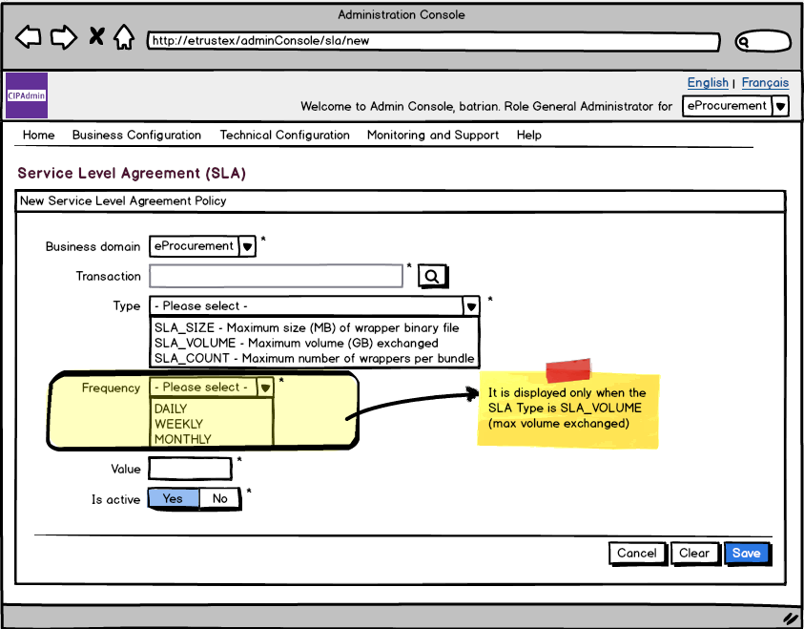
- System populates the business domain list with all the business domains the user is authorised for and defaults the selection to the current selected business domain in the application header.
- Transaction field is read-only. It shall be automatically filled in with the transaction name, follow by a dash and the transaction version (pattern «TransactionName - TransactionVersion») of the transaction selected in the transaction search screen. The transaction search screen is accessible via the search button next to the transaction field.
- The SLA type field is populated as described in section 6.4 Code lists. No default selection.
- The SLA frequency field is populated as described in section 6.4 Code lists. It is only used when the SLA type is SLA_VOLUME and it shall only be displayed in this case. No default selection. Mandatory for SLA_VOLUME.
- Is active field default selection: «Yes»
- The business domain and type lists shall be alphabetically ordered in ascendant order and ignoring case.
- Starred fields are mandatory.
- Cancel, Clear and Save options are present.

Search SLA Policy page
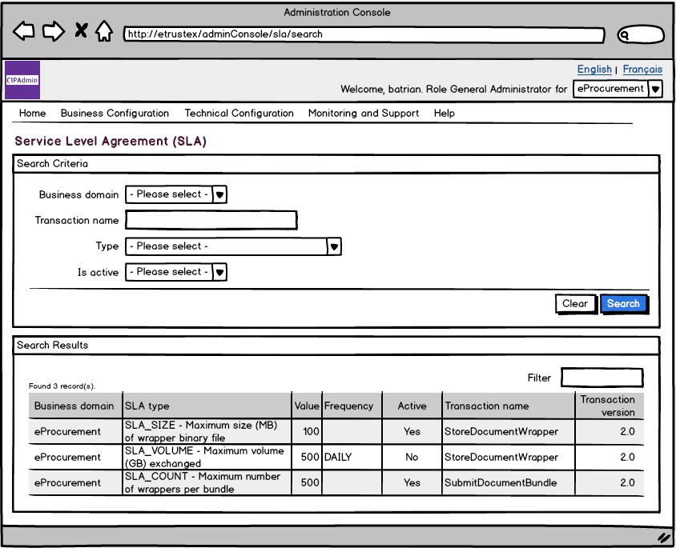
- System populates the business domain list with all the business domains the user is authorised.
- The SLA type field is populated as described in section 6.4 Code lists. No default selection.
- Is active field is populated with a list containing the Yes, No values and allowing no default selection in order to be able to search for both active and inactive SLA policies on other criteria.
- The search criteria lists shall be alphabetically ordered in ascendant order and ignoring case
- The result list shall be alphabetically ordered by transaction name in ascendant order and ignoring case and shall contain the following information:
  - the business context of the SLA policy (ie. the business domain for which it has been configured)
  - SLA type and the type description
  - SLA value
  - SLA frequency
  - Active status
  - Transaction name of the transaction for which the SLA is configured
  - Transaction version of the transaction for which the SLA is configured
- Clear and Search options are present.

View SLA Policy page
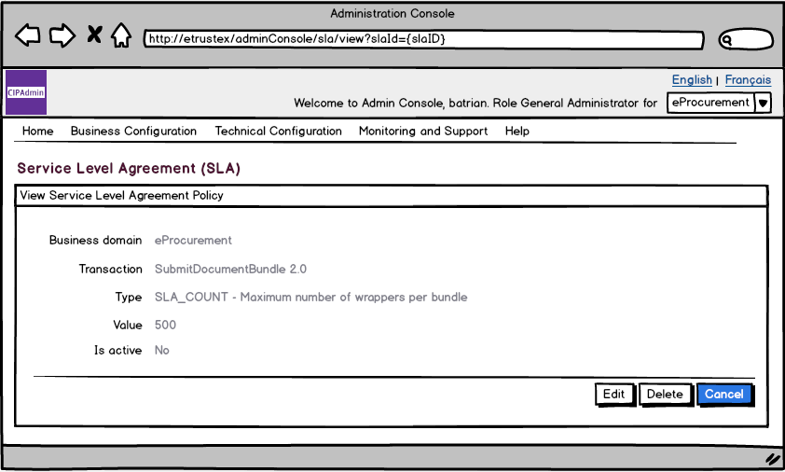
- All information on screen is read only.
- Edit, Delete and Cancel options are present.

Modify SLA Policy page
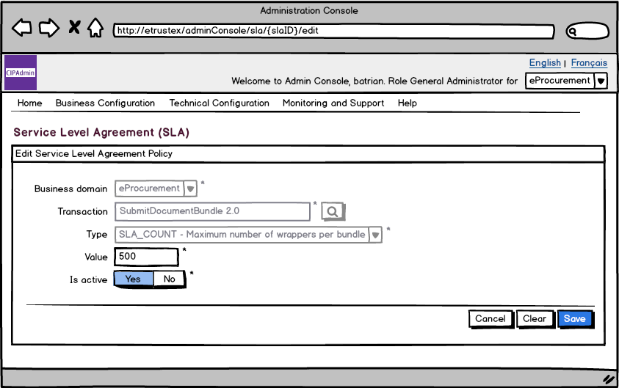
- Business domain, transaction and type are read only.
- The SLA frequency field is populated as described in section 6.4 Code lists. It is only used when the SLA type is SLA_VOLUME and it shall only be displayed in this case. No default selection. Mandatory for SLA_VOLUME.
- Starred fields are mandatory.
- Cancel, Clear and Save options are present.

Delete SLA Policy page
